NATIONAL ASSOCIATION OF UNIVERSITY WOMEN
Volume 4, Issue 5
February 2014
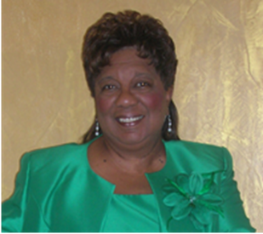
My NAUW Culver City Sisters,
CONGRATULATIONS TO OUR SOUTHWEST SECTIONAL WOMAN OF THE YEAR KENYA DENNIS!!! This is a well-deserved honor. Kenya faced stiff competition; but in the end, she emerged the victor. This is Kenya’s second time as our Southwest Sectional Woman of the Year. The Culver City Branch is very fortunate to have her as a member.
The Culver City Branch Stars were on full display Friday night at the Doubletree Hotel by Hilton Penthouse. We showed up and showed out. Our skit for the Harlem Renaissance Experience was a lot of fun. I think we all had a good time. Our performance was good enough to earn second place in the competition. We moved up one place since last. Year.
The Culver City Branch is to be applauded for hosting this year’s Southwest Sectional Conference. Our Conference Co-Chairs, Hester Watkins and Herracia Brewer did a fantastic job. Everyone pitched in and helped out when called upon. You ladies really are “STARS.” Our own Southwest Sectional Director Evelyn Wright deserves kudos for a job well done. She kept us on time and the agenda moving. She even found time to offer a few surprises for us along the way.
A special thanks goes to Kendall Dennis and her mother, Kenya Dennis. Kendall performed an amazing tap dance at our Harlem Experience on Friday night; She synchronized her steps to those of the Nicholas Brothers on film. Thanks for a wonderful routine and great performance.
February is Black History Month. We will have a special presentation at our meeting on Sunday. Don’t forget that we will be having a Soul Food Potluck on Sunday. PLEASE WEAR AFRICAN ATTIRE as we honor our Black ancestors and celebrate our culture. The list of those who signed up to bring food will be found on the following page.
Now that the SOUTHWEST SECTIONAL CONFERENCE is over, we can begin to really focus on our Community Fair Event scheduled for Saturday, April 26, 2014, at St. John’s United Methodist Church located at 1715 Santa Ana Boulevard.
SAVE THE DATE OF April 26, 2014, for the COMMUNITY FAIR.
God bless you!
Helen Ricks, President

.
CULVER CITY STAR

PRESIDENT’S CORNER
culver city nauw:

Executive Board 2012-2014

President
Helen Ricks

1st Vice President
Mildred Slaughter

2nd Vice President
Carolyn Williams

Recording Secretary
Clarissa Andrews

Corresponding Secretary
Herracia Brewer

Financial Secretary
Hester Watkins

Treasurer
Kenya Dennis

Historian
Dr. Virginia Hathaway

Parliamentarian
Dr. Claretha Graham

Immediate Past President
Mildred Slaughter

SECTIONAL DIRECTOR
EVELYN L. WRIGHT

NATIONAL PRESIDENT
DOLORES Y. OWENS

NATIONAL THEME:

“Women Moving Forward with Purpose and Pride”
CULVER CITY STAR
Page 2

SICK AND SHUT-IN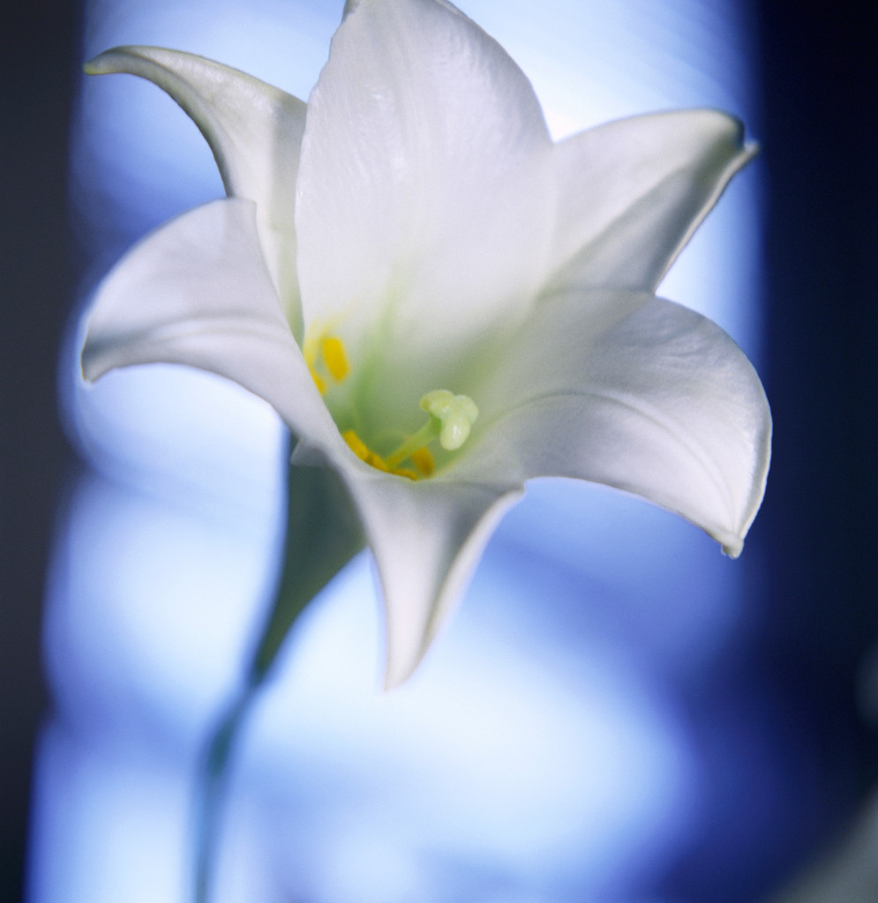
“For God has not given us the spirit of fear, but of power, and of love and of sound mind.”

2nd Timothy 1:7

BIRTHDAYS AND ANNIVERSARIES
February
Evelyn Wright 2/04

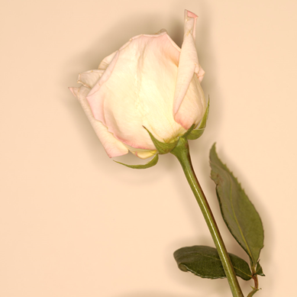
Red Dress Day Saturday, February 22, 2014 Inglewood High School Inglewood Branch
Community Fair Saturday, April 26, 2014 St. John’s UM Church 1715 Santa Ana Blvd.
Spotlight on Youth Luncheon, Sunday, April 27, 2014, 1:00 p. m. Doubletree by Hilton Torrance $65
Mailing Address: NAUW Culver City Branch P.O. Box 2524 Culver City CA 90231-2524
SOUL FOOD SIGN-UP Mildred Slaughter Cornbread Kenya Dennis –Green Bean with potatoes Herracia Brewer-Black-eyed peas Evelyn Wright- Jambalaya Mattleal Kirby- Salad Ruthie Williams – Drinks Claretha L. Graham- Mixed nuts Roberta A. Jones – Dessert Virginia Hathaway – Chips Elnora Rodgers – Turkey Loaf Helen Ricks – Baked Chicken Hester Watkins - Greens Clarissa Andrews – Mac & Cheese Carolyn Williams - Dessert

Dates to Remember

Continue to pray for the following members: Evelyn Wright and family; Odessia Love, who is recuperating; and Carolyn Williams, who is mending from a broken foot.

